CSE 4308/5360 - Fall 2007
Midterm 2, Thursday 11/15/2007

Name: .

Student ID: .

Total exam points: 100 + 20 extra credit.

Question 1

15 points + extra credit 5 points.

For of the following pairs of sentences, determine if they are logically equivalent (i.e., if each sentence of the pair implies the other sentence in the pair). Do not assume anything except the laws of propositional and first order logic.

1a. for-every x, exists y: color(x) = y
not (exists x, for-every y: not (color(x) = y) )

1b. for-every x, exists y: f(x, y)
exists y, for-every x,: f(x, y)

1c. for-every x, exists y: color(x) = y
Not (for-every x, exists y: not (color(x) = y) )

1d. (Extra credit, 5 points).
for-every x, exists y: son(x) = y
for-every x, exists y: father(y) = x

Question 2

15 points + extra credit 5 points.

Determine what is the most general unifier for each of the following pairs of expressions. The following conventions hold:
F and G are relations.
x, y, z are variables.
John and Mary are grounded symbols.

2a. F(x, y), F(y, x)

2b. F(x, y), F(John, z)

2c. F(x, y, z), F(z, G(Mary), John)

2d. Extra credit, 5 points.
F(x, g(y)), G(John, Mary)

Question 3

25 points + extra credit 5 points

3a. Consider the following set of actions:

Action(PutSockOnFoot(a, f):
Precond: Sock(a), Foot(f), FreeSock(a)
Effect: not (FreeSock(a)), SockOn(f))

Action(PutShoeOnFoot(b, f):
Precond: Shoe(b), Foot(f), SockOn(f), FreeShoe(b)
Effect: not (FreeShoe(b)), ShoeOn(f))

Now, consider this initial state, and this goal:

InitState: Sock(sock1) and Sock(sock2) and
FreeSock(sock1)and FreeSock(sock2) and
Shoe(left_shoe) and Shoe(right_shoe) and
FreeShoe(left_shoe)and FreeShoe(right_shoe)
and Foot(left_foot) and Foot(right_foot)

Goal: ShoeOn(left_foot) and ShoeOn(right_foot)

Make two different totally-ordered plans to achieve the goal, given the initial state.

3b. Consider the following set of actions (just a little different from 3a).

Action(PutSockOnFoot(a, f):
Precond: Sock(a), Foot(f)
Effect: SockOn(f))

Action(PutShoeOnFoot(b, f):
Precond: Shoe(b), Foot(f), SockOn(f)
Effect: ShoeOn(f))

Now, consider this initial state, and this goal:

InitState: Sock(sock1) and Shoe(left_shoe)
and Foot(left_foot) and Foot(right_foot)

Goal: ShoeOn(left_foot) and ShoeOn(right_foot)

Make a totally-ordered plan to achieve the goal, given the initial state.
3c. Consider the following set of actions (exactly the same as 3b).

Action(PutSockOnFoot(a, f):
Precond: Sock(a), Foot(f)
Effect: SockOn(f))

Action(PutShoeOnFoot(b, f):
Precond: Shoe(b), Foot(f), SockOn(f)
Effect: ShoeOn(f))

Now, consider this initial state, and this goal (also exactly the same as 3b).

InitState: Sock(sock1) and Shoe(left_shoe)
and Foot(left_foot) and Foot(right_foot)

Goal: ShoeOn(left_foot) and ShoeOn(right_foot)

Make a partially-ordered plan to achieve the goal, given the initial state. No order should be imposed between any two actions unless necessary (in other words, the plan should be minimally ordered).
3d. Consider the following set of actions (slightly different than 3c).

Action(PutSockOnFoot(a, f):
Precond: Sock(a), Foot(f)
Effect: SockOn(f) or SockOnFloor(a))

Action(PutShoeOnFoot(b, f):
Precond: Shoe(b), Foot(f), SockOn(f)
Effect: ShoeOn(f))

Now, consider this initial state, and this goal (exactly the same as 3b and 3c).

InitState: Sock(sock1) and Shoe(left_shoe)
and Foot(left_foot) and Foot(right_foot)

Goal: ShoeOn(left_foot) and ShoeOn(right_foot)

Is there a finite conditional plan that always achieves the goal given the initial state? If yes, describe the plan. If not, why not?

3e. Consider the following set of actions (exactly the same as 3d).

Action(PutSockOnFoot(a, f):
Precond: Sock(a), Foot(f)
Effect: SockOn(f) or SockOnFloor(a) )

Action(PutShoeOnFoot(b, f):
Precond: Shoe(b), Foot(f), SockOn(f)
Effect: ShoeOn(f) )

Now, consider this initial state, and this goal (exactly the same as 3b, 3c, and 3d).

InitState: Sock(sock1) and Shoe(left_shoe)
and Foot(left_foot) and Foot(right_foot)

Goal: ShoeOn(left_foot) and ShoeOn(right_foot)

Provide an execution-monitoring plan to achieve the goal given the initial state.
3f (extra credit, 5 points). Consider the following set of actions (exactly the same as in 3a):

Action(PutSockOnFoot(a, f):
Precond: Sock(a), Foot(f), FreeSock(a)
Effect: not (FreeSock(a)), SockOn(f))

Action(PutShoeOnFoot(b, f):
Precond: Shoe(b), Foot(f), SockOn(f), FreeShoe(b)
Effect: not (FreeShoe(b)), ShoeOn(f))

Now, consider this initial state, and this goal (also exactly the same as in 3a)

InitState: Sock(sock1) and Sock(sock2) and
FreeSock(sock1)and FreeSock(sock2) and
Shoe(left_shoe) and Shoe(right_shoe) and
FreeShoe(left_shoe)and FreeShoe(right_shoe)
and Foot(left_foot) and Foot(right_foot)

Goal: ShoeOn(left_foot) and ShoeOn(right_foot)

Give an example of a plan (sequence of actions) that does not make much intuitive sense (a person would not normally do such a thing, or would find it pretty awkward to do such a thing). What modifications to the actions and init state are needed to fix that?

Question 4

15 points

4a. Is the following function P a valid probability function? If you answer "no", explain why not.

P(car_make = Honda) = 0.7
P(car_make = Ford) = 0.4
P(car_make = BMW) = 0.1

4b. Is the following function P a valid probability density function? If you answer "no", explain why not.

P(x) = 100, if 10 <= x <= 10.01
P(x) = 0 otherwise.

4c. Is the following function P a valid probability density function? If you answer "no", explain why not.

P(x) = 0.5, if 10 <= x <= 10.01
P(x) = 0 otherwise.

Question 5

10 points

Consider the following joint probability distribution table.

Height weight < 60lb. weight60-120lb. weight > 120lb
< 3feet 0.05 0.05 0.00
3.0-3.9 feet 0.04 0.10 0.10
4.0-4.9 feet 0.01 0.15 0.15
> 5 feet 0.00 0.10 0.25

5a. Based on the above table, determine:
P(height between 3.0 and 3.9 feet | weight > 120lb ).

5b. Based on the above table, determine:
P(weight < 60 lb | height between 4.0 and 4.9 feet ).

Question 6

10 points

Compute P(fire | alarm), given the following information:

P(not alarm | fire) = A
P(alarm) = B
P(not fire) = C

.

Question 7

10 points + extra credit 5 points

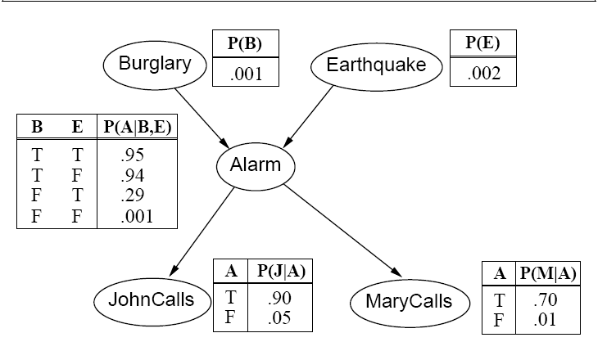

7a. Given the above Bayesian network, write the expression for:
P(Burglary and Earthquake and Alarm and JohnCalls and MaryCalls). Explain how you obtain this expression.

Do not perform additions and multiplications, but plug in all necessary numbers to fully specify the numerical value of
P(Burglary and Earthquake and Alarm and JohnCalls and MaryCalls).

7b. Given the above Bayesian network (which is the same as in 7a), consider:
A = P(JohnCalls | Alarm)
B = P(JohnCalls | Alarm and MaryCalls)

Which of the following is true: A > B, A = B, or A < B? Justify your answer.

7c (extra credit, 5 points). Given the above Bayesian network (which is the same as in 7a and 7b):

Write the expression for P(Alarm). ). Explain how you obtain this expression.
Do not perform additions and multiplications, but plug all necessary numbers to fully specify the numerical value of P(Alarm).

