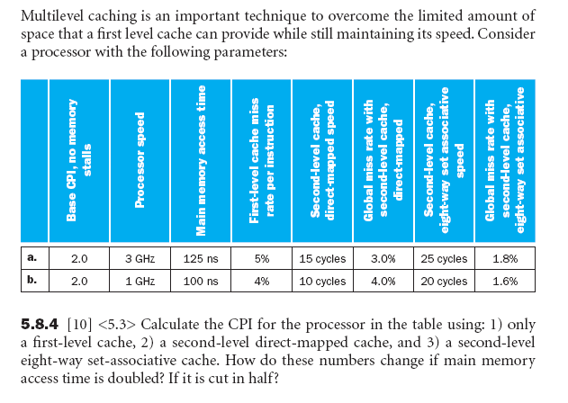
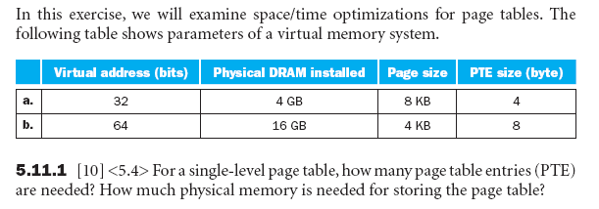

I/O 1. What is the time to transfer 8 KB from the disk under DMA?

Given: 1. OS requires 1000 clock cycles for initial set up and
500 clock cycles to handle completion interrupt
2. Clock is 1000 Mhz
3. Average transfer rate from the disk is 64 KBps

I/O 2. A keyboard transfers data to the processor in 8 bit units and has a data rate
of 10 bytes per sec. No data transfers can be missed. Consider a computer
with a 900 MHz clock rate and a polling loop of 500 clock cycles that
includes the cycles to transfer a 32 bit unit.

a.) What is the required polling rate to not miss any data?

b.) What is the % Processor Usage?

c.) Consider an interrupt driven I/O instead of polling with a interrupt routine of
750 clock cycles that includes the cycles to transfer a 8 bit unit each interrupt. If
the Keyboard is active transferring data 15% of the time, what is the %
Processor Usage?

